**HTML,CSS,JS Tutorial**



**CẤU TRÚC PROJECT**

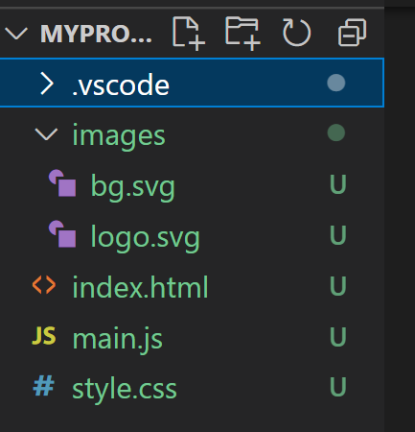

1. **Index.html**

**Import thư viện fontawesome(cdn):**    
**<link rel="stylesheet" href="https://cdnjs.cloudflare.com/ajax/libs/font-awesome/5.15.4/css/all.min.css" integrity="sha5121ycn6IcaQQ40/MKBW2W4Rhis/DbILU74C1vSrLJxCq57o941Ym01SwNsOMqvEBFlcgUa6xLiPY/NS5R+E6ztJQ==" crossorigin="anonymous" referrerpolicy="no-referrer"/>**

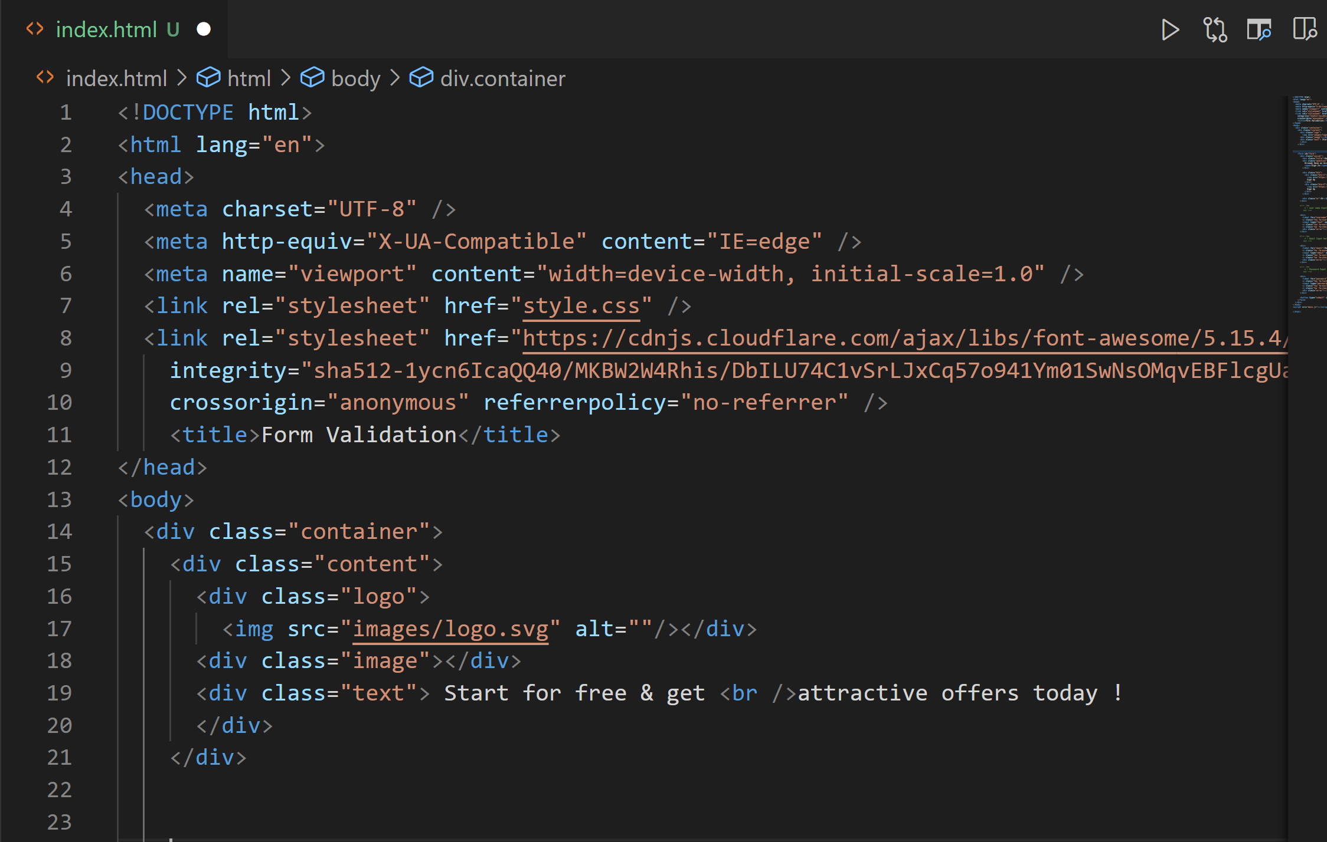

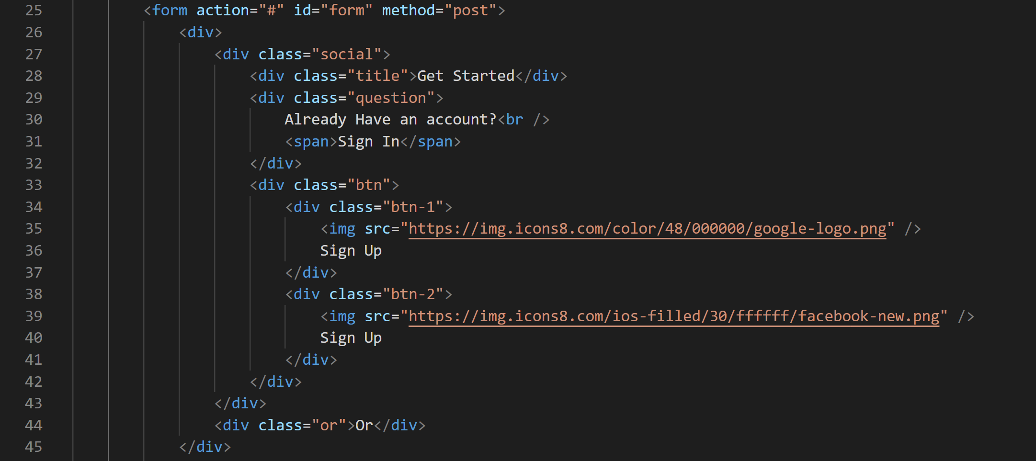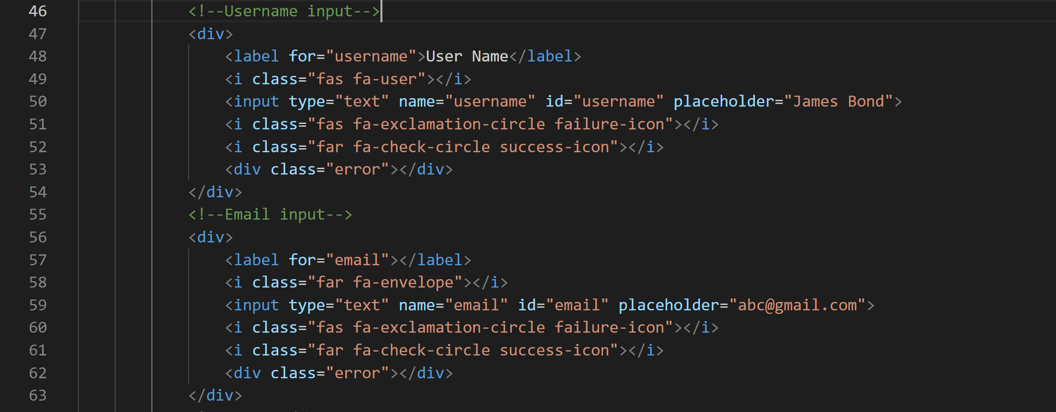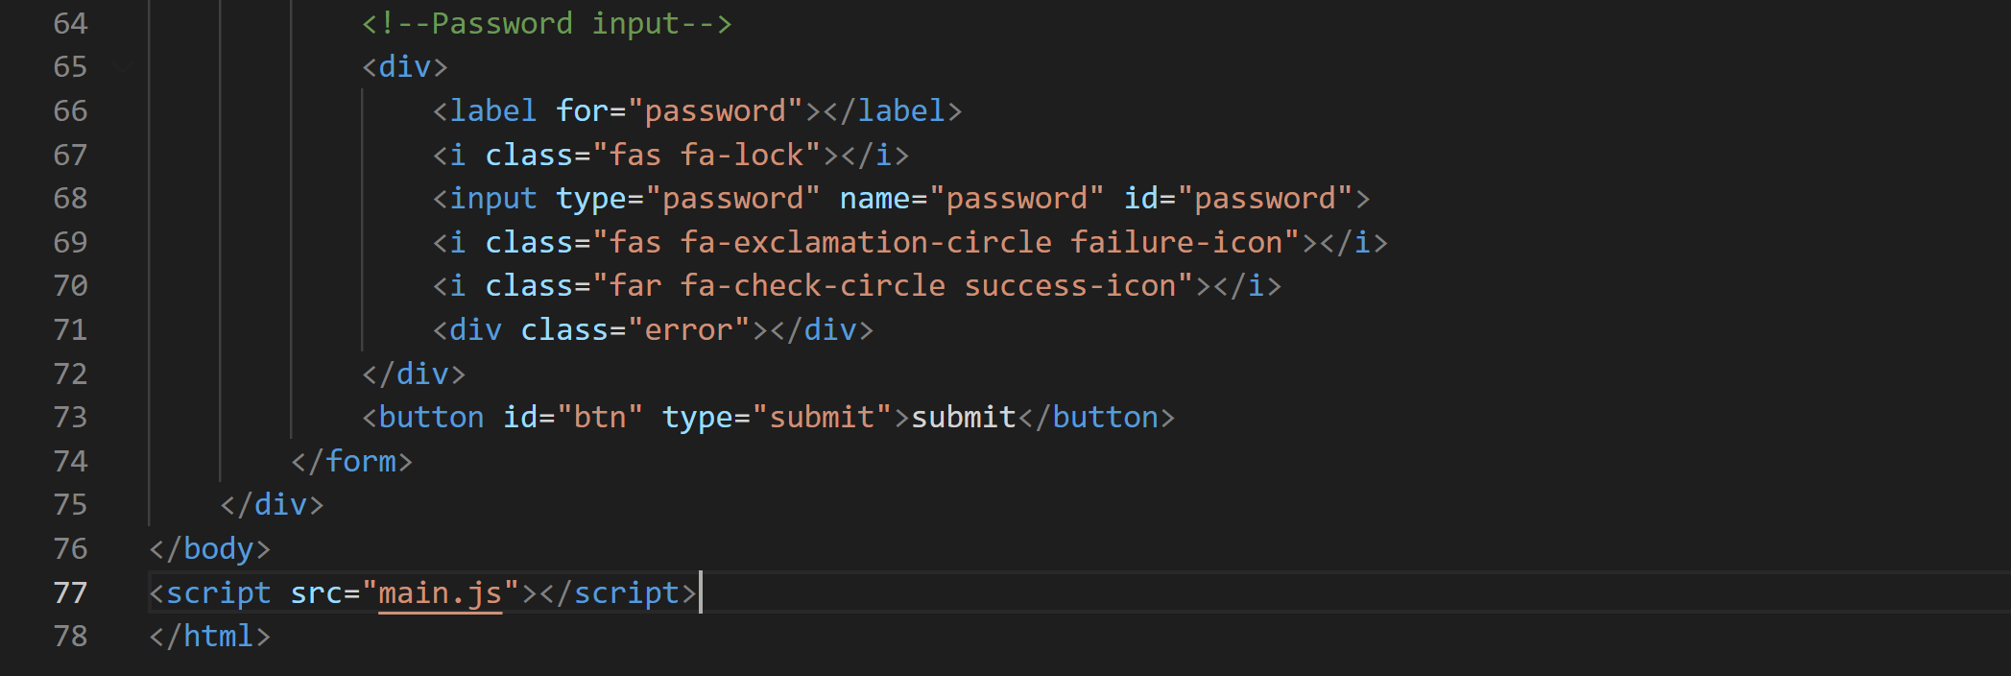

1. **Style.js**

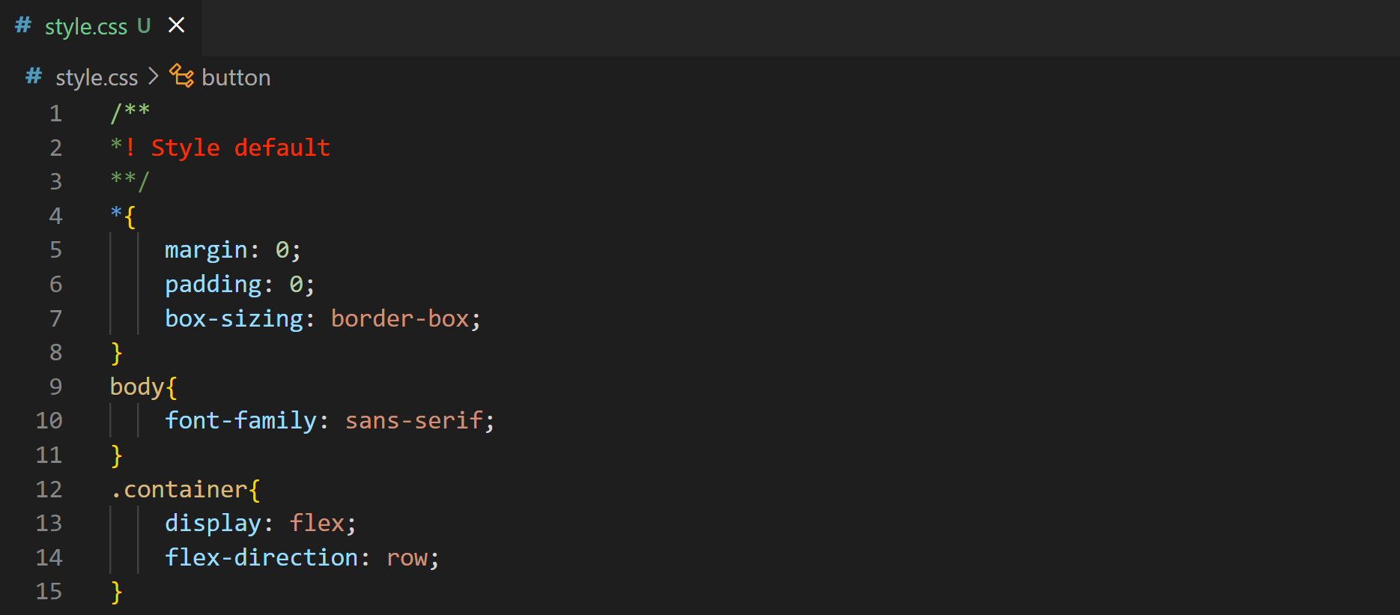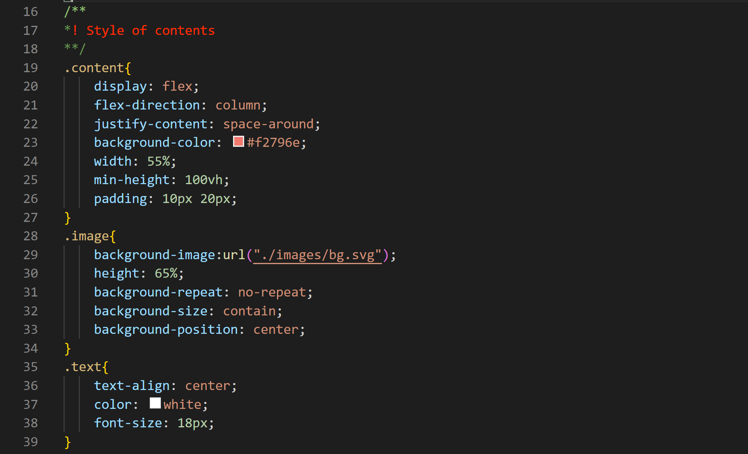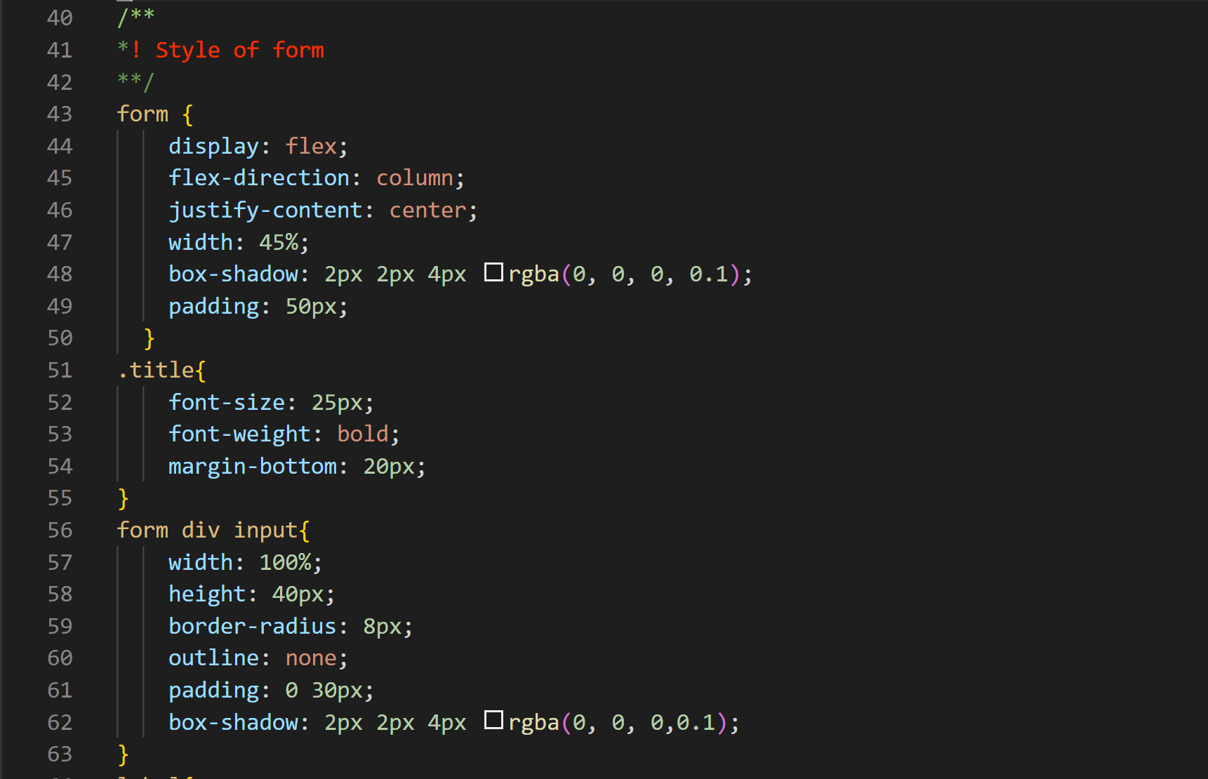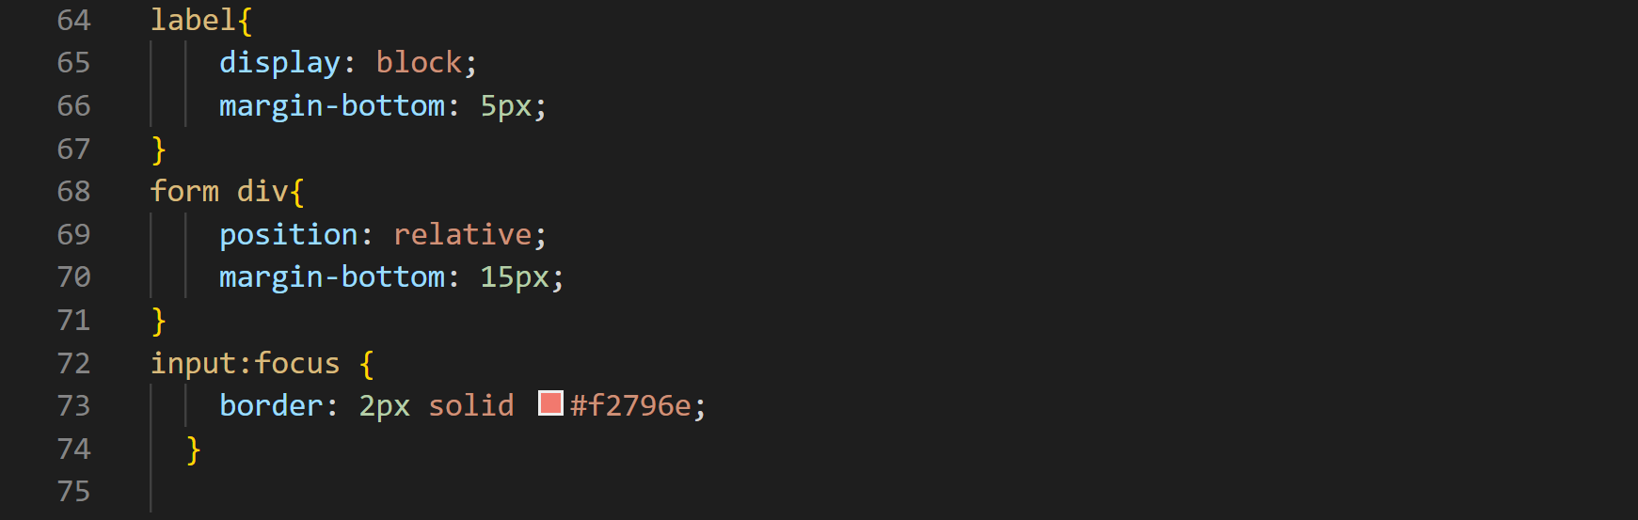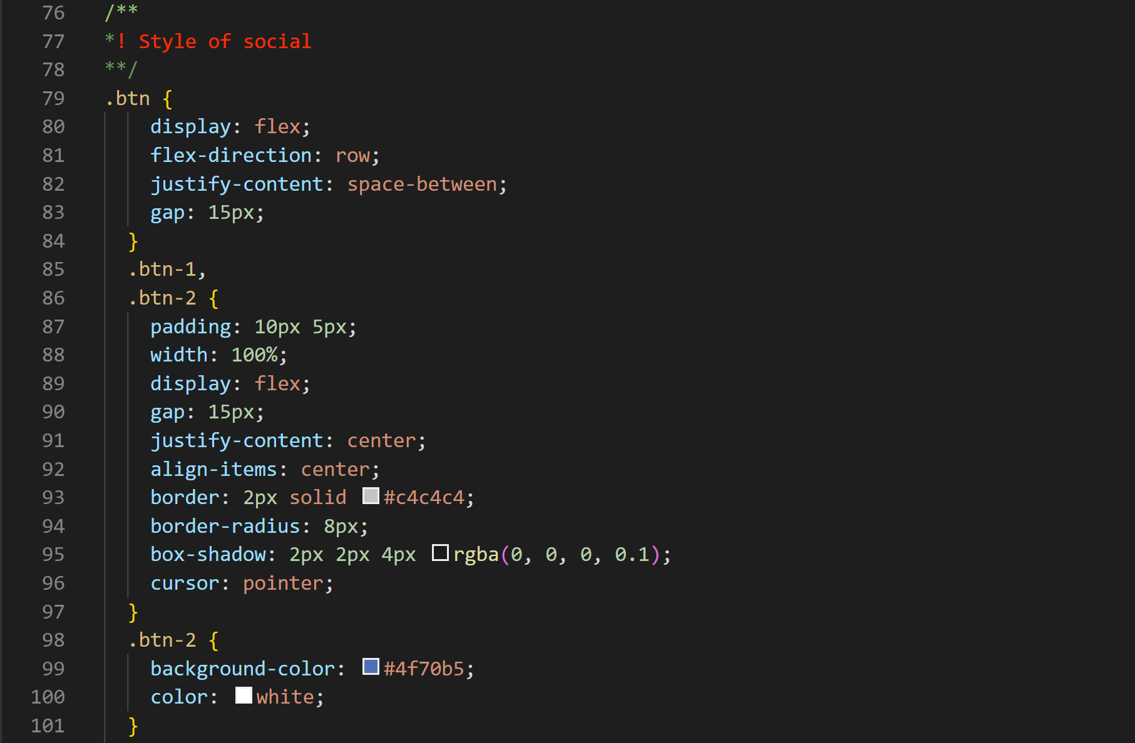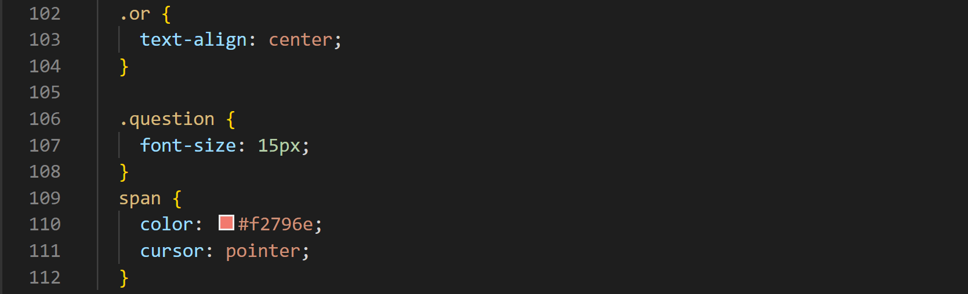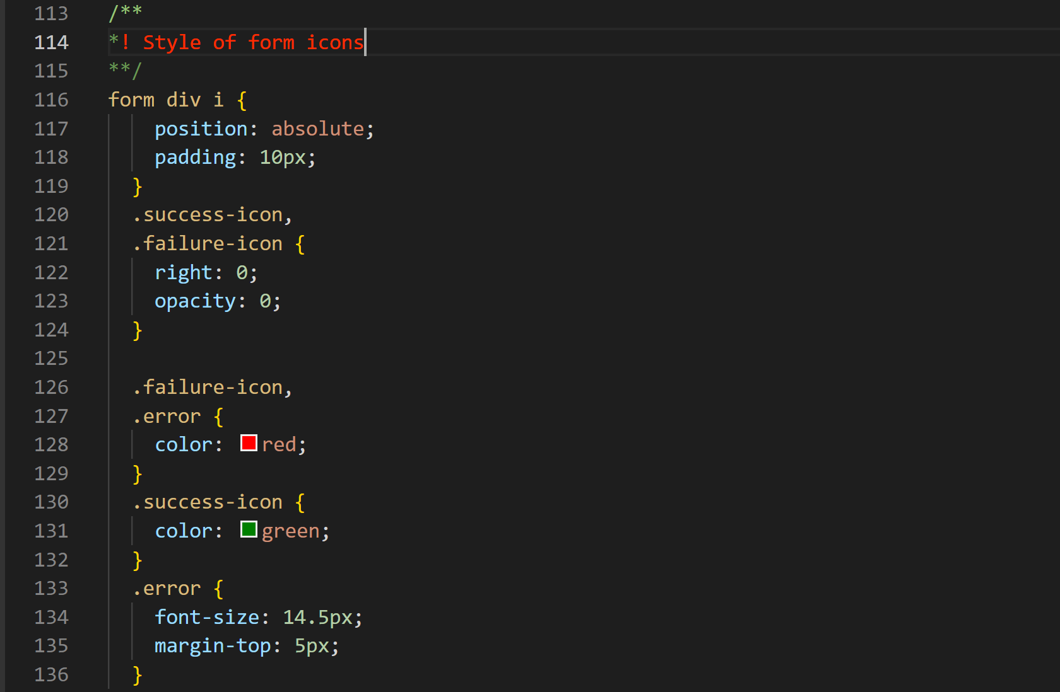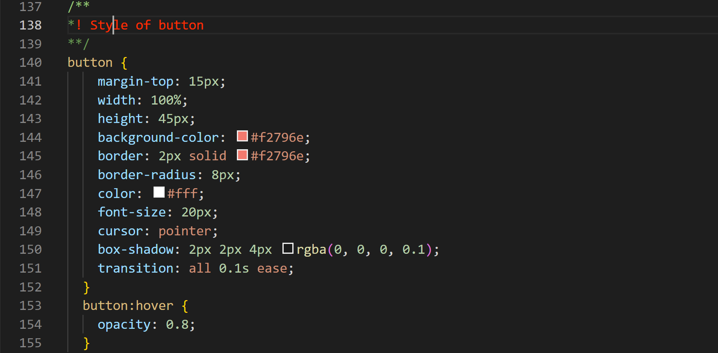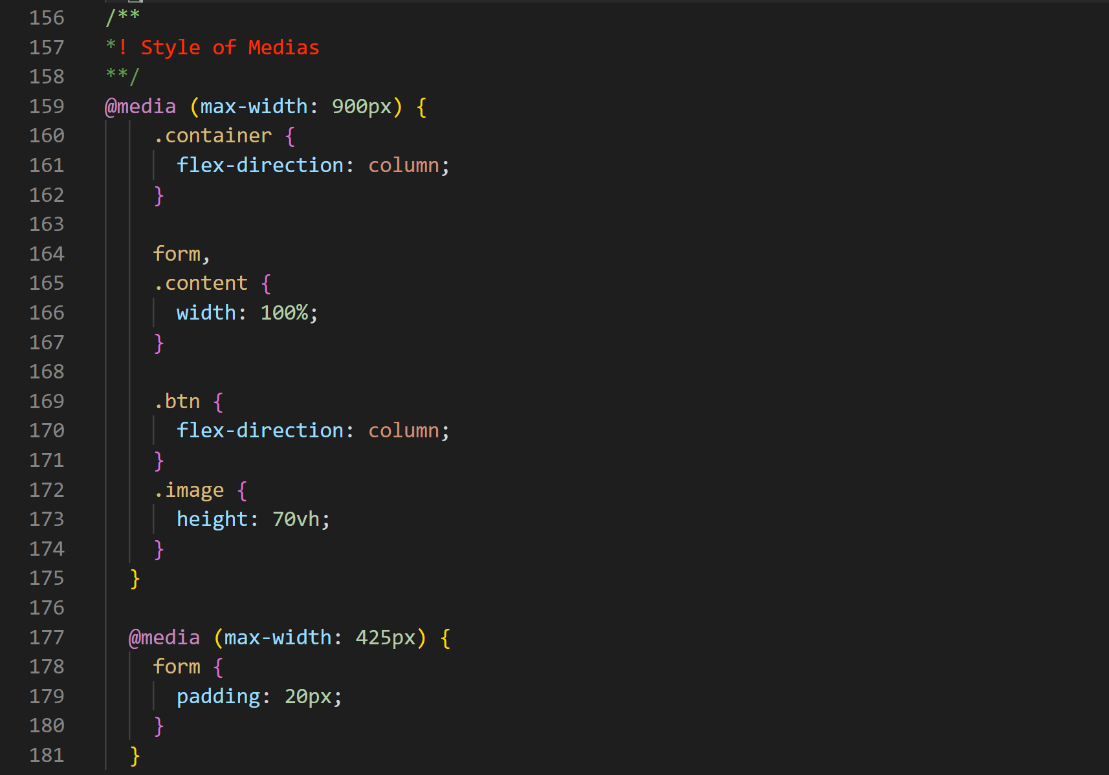

**3.main.js**

